May 2021

Dear pupils, staff and parents

You may have seen that the Government in England has discussed plans to relax rules around the use of face masks in education settings. In many areas, these changes will happen the week commencing 17th .May 2021.

However, there a few reasons why the situation in Halton is different and we need to be extra cautious:

- We have seen a COVID-19 outbreak in one of our schools in recent weeks.
- The North West of England is seeing a rapid rise in cases of a new variant of COVID-19, commonly referred to as the “Indian” variant, with several large outbreaks seen in other parts of Cheshire and Merseyside.
While the roll-out of the vaccines is progressing well, many of our education staff and parents still won’t have received their vaccination.

We must continue to be vigilant to prevent another wave of COVID-19 cases. I ask that you:

- Follow national advice and restrictions around mixing with others and do this as safely as possible. Meeting outside is still safest.
- Continue twice weekly rapid testing for COVID-19. This is for families, staff and secondary school and college students.
- Get your vaccination when you are invited.
- Self-isolate and get a PCR test (that goes to the lab) if you or anyone in your household gets symptoms.
- Remember that if you (or your child) has been in contact with someone with COVID-19, you will need to isolate for ten days, regardless of any test results you might get.
FACE COVERINGS:

I ask that face coverings continue to be worn in line with the current advice and that we don’t relax these requirements until the situation improves. As a reminder, the current advice is:

In schools where pupils in year 7 and above are educated, face coverings should be worn by adults and pupils when moving around the premises, outside of classrooms, such as in corridors and communal areas where social distancing cannot easily be maintained. In addition, face coverings should be worn in classrooms or during activities unless social distancing can be maintained. This does not apply in situations where wearing a face covering would impact on the ability to take part in exercise or strenuous activity, for example in PE lessons.
In primary schools, face coverings should be worn by staff and adult visitors in situations where social distancing between adults is not possible (for example, when moving around in corridors and communal areas). Children in primary school do not need to wear a face covering.

I understand that wearing face coverings can be inconvenient and we will review this advice as soon as we can.

Many thanks for your understanding.

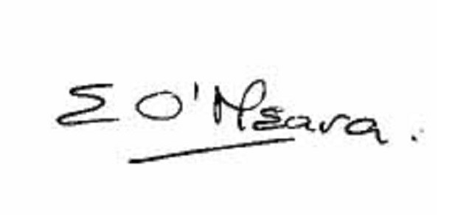

Eileen O’Meara, Director of Public Health and Health Protection
Halton Borough Council

