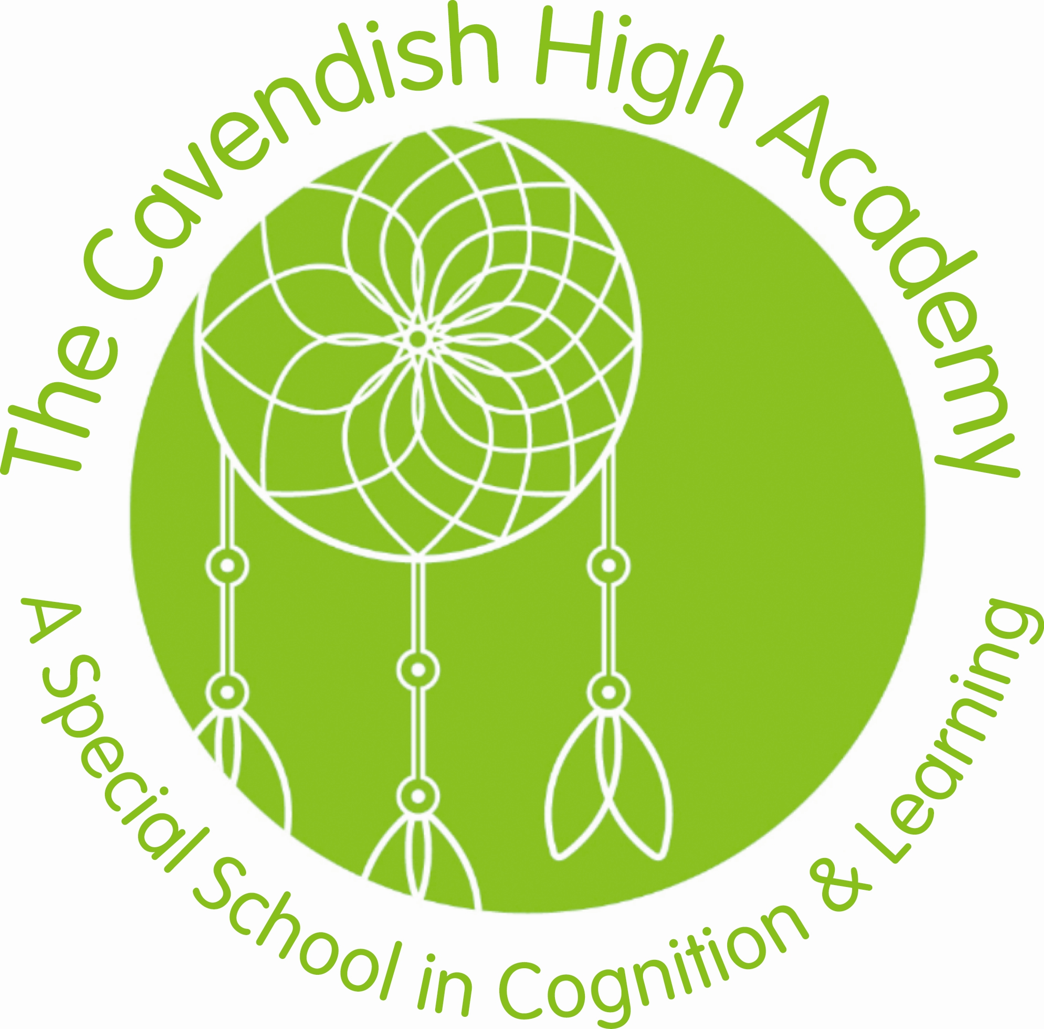

THE CAVENDISH HIGH ACADEMY
SPECIAL EDUCATIONAL NEEDS POLICY

Policy Statement Date: February 2023

Review: Change in Legislation or Redesignation

Aims

Our special educational needs and disabilities (SEND) policy aims to:
- To ensure that all systems and practices support our aims and philosophies.
- To ensure that learners have access to high quality provision & teaching as laid out in their Education, Health and Care Plans (EHCP).
- To ensure that there is equality of access to an appropriate learning environment, resources and the use of the School’s facilities.
- That all practitioners have an opportunity to actively identify and respond to the ever-changing needs of our learners.

Objectives

These aims will be met by:

- Our knowledge and understanding of the aspirations and potential of all our learners in order to support their holistic development, through offering high quality provision with high expectations.
- Ensuring that our parents and carers are actively involved in working together to maximise the achievement of outcomes.
- Working collaboratively with multi professional agencies and teams around the child to regularly review interventions, strategies and to support progress.
- Regular curriculum review and consultation to ensure our curriculum meets the needs of all our learners.
- Providing continuing professional development days (INSET) and professional dialogue days to support the development of SEND pedagogy and skills to meet the needs of our learners.
- Our Personal Learning Plans and assessment frameworks are directly constructed in response to the learners strengths and needs identified in the EHCP.

Legislation & Guidance

This is based on the statutory Special Educational Needs and Disability (SEND) Code of Practice and the following legislation:
- Part 3 of the Children and Families Act 2014, which sets out schools’ responsibilities for pupils with SEND
- The Special Educational Needs and Disability Regulations 2014, which set out local authorities’ and schools’ responsibilities for education, health and care (EHC) plans, SEN co-ordinators (SENCOs) and the special educational needs (SEN) information report
- The Equality Act 2010 (section 20), which sets out the school’s duties to make reasonable adjustments for pupils with disabilities
- The Public Sector Equality Duty (section 149 of the Equality Act 2010), which set out the school’s responsibilities to eliminate discrimination, harassment and victimisation; and advance equality of opportunity and foster good relations between people who share a protected characteristic (which includes having a disability) and those who don’t share it
- The Governance Handbook, which sets out trustees responsibilities for pupils with SEND
- The School Admissions Code, which sets out the school’s obligation to admit all pupils whose education, health and care (EHC) plan names the school, and its duty not to disadvantage unfairly children with a disability or with special educational needs

This policy also complies with our funding agreement and articles of association.

Background & Admission

The Cavendish High Academy forms part of the Halton Borough Council Children & Young Peoples Directorate SEND Local Offer and admission is through EHCP and joint negotiation with the Local Authority. The Academy is designated for 90 pupils aged 11-19 years.

The Academy will provide good value for public money and will report finances directly to The ESFA annually. All spending will be directly to the benefit of the pupils and the Academy purpose and commissioning will be in line with legal requirements. Systematic full audits of expenditure will be undertaken and published annually.

Through the Education Health & Care plan the Academy will ensure that it works closely with multi-agency teams of associated professionals.

The Academy explores all means of re-organising its resources and facilities to accommodate pupil’s needs. However, it reserves the right to review placement should this strain the resources to extreme and prevent the delivery of safe, appropriate provision for all pupils.

While not required to follow the National Curriculum (Teaching & Learning is personalised to meet the individual needs of all students and is reviewed annually).

The Academy is required to ensure the curriculum offer includes:
- English, maths and science
- Religious Education
- Access to Sex and Relationship Education (SRE)
- Access to Independent, Impartial Careers Advice

Special educational provision is educational or training provision that is additional to, or different from, that made generally for other children or young people of the same age by mainstream schools.
The Cavendish High Academy SEN Policy falls under (b) of the Code of Practice and is a Special School for pupils aged 11-19 years with a designated SEN category (2014) for:
- Profound & Multiple Learning Difficulties (PMLD)
- Severe Learning Difficulties (SLD)
- Autistic Spectrum Disorder (ASD) + (SLD)

A pupil has SEN if they have a learning difficulty or disability that requires special educational provision to be made for them.
They have a learning difficulty or disability if they have:
- A significantly greater difficulty in learning than most others of the same age, or
- A disability which prevents or hinders them from making use of facilities of a kind generally provided for others of the same age in mainstream schools
- Pupils are considered to have a disability if they have a physical or mental impairment that has a substantial and long-term adverse effect on their ability to do normal daily activities.

The 4 areas of need
The needs of pupils with SEND are grouped into 4 broad areas. Pupils can have needs that cut across more than 1 area, and their needs may change over time.
Interventions will be selected that are appropriate for the pupil’s particular area(s) of need, at the relevant time.

Area of need

Communication and interaction | Pupils with needs in this area have difficulty communicating with others. They may have difficulty understanding what is being said to them, have trouble expressing themselves, or do not understand or use the social rules of communication.  Pupils who are on the autism spectrum often have needs that fall in this category.
Cognition and learning | Pupils with learning difficulties usually learn at a slower pace than their peers.  A wide range of needs are grouped in this area, including:  - Specific learning difficulties, which impact 1 or more specific aspects of learning, such as: dyslexia, dyscalculia and dyspraxia  - Moderate learning difficulties  - Severe learning difficulties  - Profound and multiple learning difficulties, which is where pupils are likely to have severe and complex learning difficulties as well as a physical disability or sensory impairment
Social, emotional and mental health | These needs may reflect a wide range of underlying difficulties or disorders. Pupils may have:  - Mental health difficulties such as anxiety, depression or an eating disorder  - Attention deficit disorder, attention deficit hyperactive disorder or attachment disorder  - Suffered adverse childhood experiences  These needs can manifest in many ways, for example as challenging, disruptive or disturbing behaviour, or by the pupil becoming withdrawn or isolated.
Sensory and/or physical | Pupils with these needs have a disability that hinders them from accessing the educational facilities generally provided.  Pupils may have:  - A sensory impairment such as vision impairment, hearing impairment or multi-sensory impairment  - A physical impairment  These pupils may need ongoing additional support and equipment to access all the opportunities available to their peers.

SEN information report

The school publishes a SEN information report on its website (and as part of the local offer for Halton) which sets out how this policy is implemented in the school including provision, resources & staff training.

The information report is updated annually and/or as soon as possible after any changes to the information it contains.

Roles

In our school all teachers act as SENCOs. With a SENCO co-ordinator role held by an assistant principal.

The Principal has overall responsible for the policy update and any required amendments though this may be a delegated duty to a member of the SLT.

We have a Student Support & Family Liaison Manager who is a member of the SLT and is supported by a team of HLTAs & TAs.

Expertise and training of staff

As a Special School we are committed to continuous professional development for all our staff to ensure that they have the skills, knowledge and understanding to support all our learners. Training needs will be determined by role, appraisal and performance management, and in response to learner need and expertise.

Multi-agency working

The school recognises that it won’t be able to meet all the needs of every pupil.
We are committed to working in partnership with other agencies to support the needs of our learners. Whenever necessary and possible the school will work with external support services such as:
- Speech and language therapists
- Specialist teachers or support services
- Educational psychologists
- Occupational therapists
- Physiotherapists
- General practitioners or paediatricians
- School nurses
- Child and adolescent mental health services (CAMHS)
- Education welfare officers
- Social services

Parent/carer partnership

Cavendish High Academy is committed to working in partnership with our families to help learners achieve their aspirational outcomes, develop their independence, celebrate their individuality and prepare for next steps. We welcome families at the beginning of their child’s journey with us and aim to develop and maintain relationships that are sustained after young people move on from us. We offer families a range of groups, targeted intervention and training to enable them to have a better understanding of their child’s needs and to support them to make good progress in their learning and development.
We periodically capture the progress of our learners tand share this with our families through the Earwig online platform. Parents/carers are invited to discuss any issues with teaching teams and other professionals through informal face to face meetings, drop in sessions, or more formalised meetings.

EHCP Reviews

- The Senior Leadership Team co-ordinate Annual Review and Education, Health and Care Plan meetings as required and at least annually. The meetings are led by the class teacher.
- EHC Plan Transition Statements at Years 6 (on entry), 9 and 13 as part of the EHCP
- The decision to amend an Education, Health and Care plan, or funding allocation is made by the Local Authority although the school will make recommendations based on evidence gathering in school.
- When changes are made, the Local Authority informs parents initially and then the school in writing and the amended Education, Health and Care Plan or Statement follows; the amended legal document is then placed in the learners electronic folder.
- Each learner has a personal learning plan (PLP).
- Each learner has a folder on the shared drive where all the documents and reports associated with an annual review, Education, Health and Care Plan or Statement are filed.

Preparation for adulthood – transition

For our learners in sixth form, we offer a curriculum that focuses on becoming independent, accessing the local community and gaining vocational skills to support their transition into adulthood. The aspirations identified in their Education, Health and Care Plans will be key factors in developing their learning programme. As a pathway to their next placement, wherever possible learners participate in meaningful work experience both in school and in the community. We also provide support and preparation for post-school supported internships.

Transition is discussed with parents, carers and young people to plan the most appropriate next steps. Our priority is to ensure that all our learners can communicate effectively, feel confident in their new environment and are prepared for the challenges of adulthood.

In Conclusion

The Cavendish High Academy SEND Policy underpins the attitudes, values, ethos of the school and policy is based on the agreed aims. The school is part of multi-agency working that includes colleagues from the Local Education Authority, Schools Support Services, Educational Psychology Service, CAHMS, NHS Trust, local hospitals and hospices, Social Services. The Academy is further supported through close partnership with parents and the local community, to enable us to reach our aim in achieving the highest expectations for our children and young people.

SIGNED ON BEHALF OF THE GOVERNING BODY ……………………………………..

DATE …………………………….

