Pupil premium strategy statement – The Cavendish High Academy – 2021 - 2024
This statement details our school’s use of pupil premium (and recovery premium) funding to help improve the attainment of our disadvantaged pupils.
It outlines our pupil premium strategy, how we intend to spend the funding in this academic year and the outcomes for disadvantaged pupils last academic year.

School Overview
Detail | Data
Number of pupils in school | 101
Proportion (%) of pupil premium eligible pupils | 60%
Academic year/years that our current pupil premium strategy plan covers (3 year plans are recommended) | 2021 - 2024
Date this statement was published | December 2022
Date on which it will be reviewed | July 2024
Statement authorised by | Elaine Haver  Principal
Pupil premium lead | John Munro  Assistant Principal
Governor / Trustee lead | Lisa McMillan

Funding overview £87,217
Detail | Amount
Pupil premium funding allocation this academic year | £45,679
Recovery premium funding allocation this academic year | £41,538
Pupil premium (and recovery premium*) funding carried forward from previous years (enter £0 if not applicable)  *Recovery premium received in academic year 2021 to 2022 can be carried forward to academic year 2022 to 2023. Recovery premium received in academic year 2022 to 2023 cannot be carried forward to 2023 to 2024. | £0
Total budget for this academic year  If your school is an academy in a trust that pools this funding, state the amount available to your school this academic year | £87,217

Part A: Pupil premium strategy plan

Statement of intent
The Pupil Premium Grant (PPG) 2022-2023 provides funding to continue raising the attainment of disadvantaged pupils and closing the gap with their peers. As a school, we have the responsibility for using this funding to close the gap and ensure we have high expectations of all as we level up attainment for our learners. We ensure the best possible support for raising attainment for the most vulnerable pupils. Equality remains the core of all we do at Cavendish.
At the heart of our approach is high-quality teaching focussed on areas where our pupils require it most, targeted support & interventions based on robust diagnostic assessment of need, and helping pupils to access an appropriate, relevant, broad and balanced curriculum.
Although pupil premium funding and strategy is focused on the needs of disadvantaged pupils in our school context this equates to approximately ¾ of the school so the non-disadvantaged pupils are actually in the minority. The strategy will benefit all pupils in our school where funding is spent on whole-school approaches, such as specialist staffing and additional intervention support that complements and supports high-quality teaching. Implicit in the intended outcomes detailed below, is the intention that outcomes for non-disadvantaged pupils will be improved alongside progress for their disadvantaged peers.
We will also provide disadvantaged pupils with support to develop independent life and social skills and continue to ensure that high-quality work experience, career guidance and further and higher education guidance is available to all.
- Our strategy will be driven by the needs and strengths of each young person, based on formal and informal assessments, not generalised assumptions, or labels. This will help us to ensure that we offer them the relevant support to develop the skills and experience they require to be appropriately prepared for adulthood.

Challenges
This details the key challenges to achievement that we have identified among our disadvantaged pupils.
Challenge number | Detail of challenge
1 | Some students who are eligible for pupil premium have challenges with communicating and expressing their needs including non-verbal, limited language and social interaction difficulties and require additional speech & language & communication support.
2 | Through reviewing EHCP and assessment data it is evident that cognitive impairment affects some disadvantaged pupil’s ability to acquire literacy skills to a significant degree. Low attainment in reading can be a barrier to attainment in a range of curriculum subjects as well as potentially limiting independence for a number of disadvantaged pupils.
3 | Some students, who are eligible for pupil premium, have issues with their mental health and well-being that impacts on school attendance and or readiness for learning.
4 | Some students require additional support to develop personal independence skills including for example independent travel and accessing enrichment activities outside of school.
5 | A cohort of students have been exposed to emotional, physical and sexual trauma. Post traumatic effects can limit engagement, trigger emotional responses, and increase behavioural incidents. These students therefore require additional support with trauma response behaviours following COVID and a succession of lockdowns.
6 | Through reviewing EHCP and assessment data it is evident that cognitive impairment affects some disadvantaged pupil’s ability to acquire numeracy skills to a significant degree. Low attainment in numeracy can be a barrier to attainment in a range of curriculum subjects as well as limiting financial independence for some disadvantaged pupils.
7 | Combat hunger and the impact of the cost-of-living crisis on our pupils readiness for learning

Intended outcomes
This explains the outcomes we are aiming for by the end of our current strategy plan, and how we will measure whether they have been achieved.
Intended outcome | Success criteria
Improved communication, speech & language for pupils identified as needing additional support. | Pupil engagement in S&L intervention and support and developments in their S&L as assessed through achievement of relevant targets on PLP as well as through appropriate assessment framework e.g. Progression Steps, AFLS,ABBLS-r, AET Autism, Blank levels.
Improved attainment in reading | Pupil engagement in reading intervention and support and achievement of relevant targets on PLP/EHCP and through appropriate assessment frameworks
Improvements in mental health and well-being. | Intervention data and assessment data on relevant framework will illustrate progress and also attainment of PLP targets. Improved engagement and /or school attendance data for specific pupils.
Greater confidence and independence to help them engage more with the wider community and prepare for adulthood. | Attainment of PSHE target on PLP/EHCP. Completion of independent travel training program. A student may begin to independently travel to and from school. Through observations and discussions with pupils and their families.
Develop a commitment to improving the health, wellbeing and ability to learn of our most vulnerable students, namely those who have suffered trauma, abuse, neglect and/or have mental health problems or attachment issues. | Reduced behavioural episodes linked to trauma, development of healthy coping skills and a decrease in traumatic stress symptoms for students.
Improved attainment in numeracy | Pupil engagement in numeracy intervention and support and achievement of relevant targets on PLP/EHCP and through appropriate assessment frameworks
Introduction of breakfast club | According to a government study, pupils being hungry has been linked with poor concentration in class. Breakfast clubs can have positive impacts on pupils’ ability to concentrate, and pupils who have eaten breakfast are more prepared to learn.  Breakfast Clubs Setup and Implementation

Activity in this academic year
This details how we intend to spend our pupil premium (and recovery premium) funding this academic year to address the challenges listed above.

Teaching (for example, CPD, recruitment and retention)
Budgeted cost: £ 54,906.22
Activity | Evidence that supports this approach | Challenge number(s) addressed
Maintenance of 2 HLTA posts to support and deliver a range of interventions across the school. | The Communication Trust worked with the Better Communication Research Programme to develop the What Works database of evidenced interventions to support children’s speech, language and communication.  What works database (ican.org.uk)  This has been endorsed by the Royal College of Speech and Language Therapists. | 1,2,3 & 4  £29124.34  **Contribution towards salary and oncosts
Maintenance of 1 TA posts to support and deliver a range of interventions across the school. | Targeted academic interventions in numeracy, literacy and reading, these are targeted to meet the specific needs of Pupils with SEND  Teaching Assistant deployment and interventions to support ASDAN and exam Preparation | 2, 6  £6075.86  £5293.36  £15791.01 **Contribution towards salary and oncosts
Whole staff Phonics CPD  Read,Write Inc Fresh Start. | Majority of feeder schools use Read, Write Inc phonics programme – continuity.  The Education Endowment Foundation recently ran a project investigating the effectiveness of Fresh Start, which found that the intervention shows considerable promise as an effective catch-up intervention for low-attaining readers at the transition phase from primary to secondary school. The study found a mean effect size of +0.24 in secondary reading.  Read, Write, Inc Fresh Start has age-appropriate resources for older readers and adults.  KEY RESEARCH  The Education Endowment Foundation evaluation found that continuous feedback to teachers and support from trainers assists successful implementation of the intervention.  https://educationendowmentfoundation.org.uk/projects-and-evaluation/projects/fresh-start/  The Education Endowment Foundation is now running a further project to investigate the effectiveness of Fresh Start and Read-Write Inc Phonics. The evaluation should be available in 2023  https://educationendowmentfoundation.org.uk/projects-and-evaluation/projects/read-write-inc-and-fresh-start/ | 2  £3537.00

Targeted academic support (for example, tutoring, one-to-one support, structured interventions)
Budgeted cost: £9620.11
Activity | Evidence that supports this approach | Challenge number(s) addressed
HLTA interventions | Understanding the meaning of a text requires a combination of word recognition and language comprehension:  Learning to Read: “The Simple View of Reading” | National Center on Improving Literacy | 2  £5615.57
Talk and Draw | HLTA led therapeutic intervention that focuses on individuals or groups of children dependent on need. This intervention is carried out at the pupils’ own pace and their current state of wellbeing. | 2,3,5  £4004.54

Wider strategies (for example, related to attendance, behaviour, wellbeing)
Budgeted cost: £ 15,221.84
Activity | Evidence that supports this approach | Challenge number(s) addressed
Enhancing the sensory regulation equipment available for PP learners with enhanced sensory needs, including autism. We will also fund staff training. | We have observed that sensory equipment and resources such as mattresses, lap pads, tunnels, weighted jackets, and additional proprioceptor equipment can effectively support our pupils with sensory needs. | £2356
Training pupils to use public transport.  This will involve CPD and release time for two staff members. | Independent Travel Training is likely to enhance pupils’ social and employment opportunities:  Department for Education (publishing.service.gov.uk) | 4  £80
DESTY | Broaden Desty Island Emotional Resilience programme.  Children visit DESTY Island online with their trained DESTY mentor is someone in their lives such as a parent, carer, or educator. There they meet our wonderful character DESTY who acts as their island guide and friend. This is a one-to-one programme where child and mentor work together over an average of fourteen 30–40-minute guided sessions aimed at building children’s emotional resilience.  Evidence Based: Our pilot study found that 80% of children who used the DESTY® Island Programme improved their emotional wellbeing.  Evaluation of Outcomes: We provide easy access to pre and post Strengths and Difficulties Questionnaire (SDQ) so mentors can track improvements in the child's wellbeing and behaviour. | 3,4,5,  Subscription  £490.00  Implementation and curriculum time  £7891.84
The Good Life  Wellbeing and counselling service | Dramatherapy  (Specialising in Trauma & PTSD)  Drama therapist specialising in trauma recovery and the treatment of PTSD.  Counsellor has worked in a variety of different fields such as refugees and asylum seekers, children with severe and life-limiting disabilities as well as working with those who have experienced abuse, neglect, anxiety and depression. | 5  £6,840.00
Breakfast Club | Breakfast clubs can reduce the number of pupils coming to class hungry.  Many pupils would not be eating breakfast if a breakfast club were not available.  As a school we have opted to offer and promote the breakfast club to all pupils.  This approach is beneficial; as well as maximising the number of pupils who attend, it helps avoid any stigma that might become attached to the club if attendance is restricted to a core group of pupils.  ** Costs to be confirmed | 7  £607.48

Total budgeted cost: £ 87807.00

Part B: Review of the previous academic year

Outcomes for disadvantaged pupils

Pupil premium strategy outcomes 22/23
51 pupils were entitled to Pupil Premium across the school, accounting for 51% of the whole school population, 35 of whom were male (68%) and 16 were female (32%). These pupils only appear in key stages 3 and 4. PP students make up 69% of the population of KS3/4
There were 59 pupils entitled to free school meals across the Academy, these pupils accounted for 59% of the whole school population of these 38 were male (64%) and 21 were female (36%).
There were 7 looked-after pupils in the Academy, (7% of the whole school population) of those 4 were male (57% of the cohort) and 3 of those were female (43% of the cohort).
Overall progress of pupils in receipt of Pupil Premium
- 88% of pupils made expected progress or above expected progress in English
- 93% of pupils made expected progress or above expected progress in Mathematics
- 84% of pupils made expected progress or above expected progress in PHSE

Pupil Premium students have performed particularly well with +15% in English, +19% in Mathematics and +12% in PHSE once again significant uplifts from the Spring term data.
Overall progress of pupils who are looked after
- 86% of pupils made expected progress or above expected progress in English
- 100% of pupils made expected progress or above expected progress in Mathematics
- 86% of pupils made expected progress or above expected progress in PHSE
The substantial advancements achieved throughout the school have also been replicated in our group of looked-after children, 86% of whom exceeded expectations in all core subjects. Additionally, 100% of this group met or surpassed the expected targets in Mathematics.

Pupil premium strategy outcomes 21/22
Pupil Premium - English
For the purpose of this dataset there are 43 students in the main bulk of the cohort, 6 Pupil Premium pupils are assessed using ‘Engagement Steps’, the whole cohort consists of 49 pupils, 34 of which are male accounting for 79% of this cohort, 15 are female accounting for 31% of this cohort, 43 of these pupils are assessed using ‘Progression Steps’.
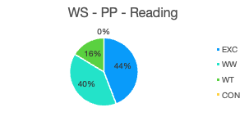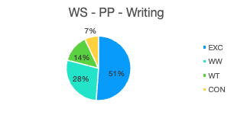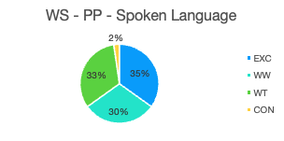
In reading 84% of pupils (36 pupils) are exceeding or working within their targets, in writing 79% of pupils (34 pupils) are exceeding or working within their targets and in Spoken language 65% (28 pupils) are exceeding or working within their targets.
69% of females are working within or exceeding their targets in reading while 90% of males are excelling in the same dataset. In writing 77% of females are working within or exceeding their targets 80% of males are working within or exceeding their targets in this area. 85% of females are working within or exceeding their targets in spoken language outperforming the 57% of males who are excelling in the same dataset.
FSM
For the purpose of this dataset there are 52 students in the main bulk of the cohort, 32 of which are male accounting for 61% of this cohort, 20 are female accounting for 38% of this cohort.

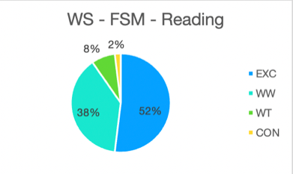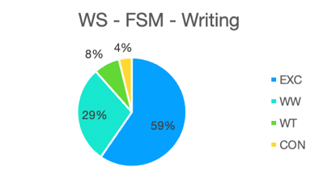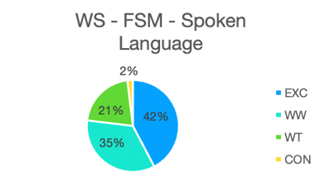

In reading 90% of pupils (47 pupils) are exceeding or working within their targets, in writing 88% of pupils (46 pupils) are exceeding or working within their targets and in Spoken language 77% (40 pupils) are exceeding or working within their targets.
80% of females are working within or exceeding their targets in reading while 97% of males are excelling in the same dataset. In writing 80% of females are working within or exceeding their targets 94% of males are working within or exceeding their targets in this area. 80% of females are working within or exceeding their targets in spoken language whilst 75% of males are excelling in the same dataset.
LAC
For the purpose of this dataset there are 9 students in the cohort, 6 of which are male accounting for 54% of this cohort, 3 are female accounting for 46% of this cohort.
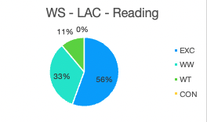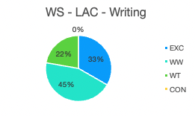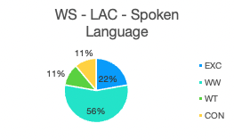
In reading 89% of pupils (8 pupils) are exceeding or working within their targets, in writing 78% of pupils (7 pupils) are exceeding or working within their targets and in Spoken language 78% (7 pupils) are exceeding or working within their targets.
100% of females and 80% of males are working within or exceeding their targets in reading. In writing 100% of females are working within or exceeding their targets 67% of males are working within or exceeding their targets in this area. 100% of females are working within or exceeding their targets in spoken language whilst 60% of males are excelling in the same dataset.
Pupil Premium - Mathematics
For the purpose of this dataset there are 43 students in the main bulk of the cohort, 6 Pupil Premium pupils are assessed using ‘Engagement Steps’, the whole cohort consists of 49 pupils, 34 of which are male accounting for 79% of this cohort, 15 are female accounting for 31% of this cohort, 43 of these pupils are assessed using ‘Progression Steps’.

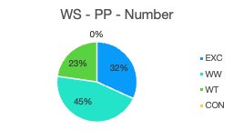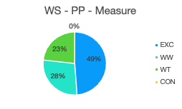
In number 77% of pupils (34 pupils) are exceeding or working within their targets, in measure 77% of pupils (33 pupils) are exceeding or working within their targets.
79% of females are working within or exceeding their targets in number while 74% of males are excelling in the same dataset. In measure 71% of females are working within or exceeding their targets 82% of males are working within or exceeding their targets in this area.
FSM
For the purpose of this dataset there are 52 students in the main bulk of the cohort, 32 of which are male accounting for 61% of this cohort, 20 are female accounting for 38% of this cohort.
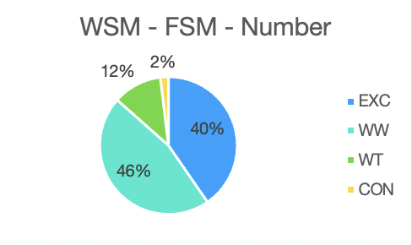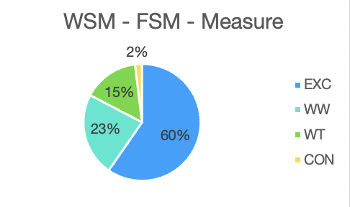
In number 86% of pupils (44 pupils) are exceeding or working within their targets, in measure 83% of pupils (43 pupils) are exceeding or working within their targets.
80% of females are working within or exceeding their targets in number while 91% of males are excelling in the same dataset. In measure 80% of females are working within or exceeding their targets 84% of males are working within or exceeding their targets in this area.
LAC
For the purpose of this dataset there are 9 students in the cohort, 6 of which are male accounting for 54% of this cohort, 3 are female accounting for 46% of this cohort.

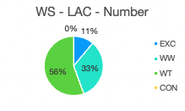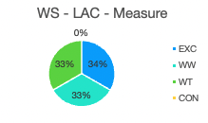
In number 89% of pupils (8 pupils) are exceeding or working within their targets, in measure 67% of pupils (6 pupils) are exceeding or working within their targets.
33% of females and 50% of males are working within or exceeding their targets in number. In measure 33% of females are working within or exceeding their targets 83% of males are working within or exceeding their targets in this area.
Pupil Premium - PHSE
For the purpose of this dataset there are 43 students in the main bulk of the cohort, 6 Pupil Premium pupils are assessed using ‘Engagement Steps’, the whole cohort consists of 49 pupils, 34 of which are male accounting for 79% of this cohort, 15 are female accounting for 31% of this cohort, 43 of these pupils are assessed using ‘Progression Steps’.
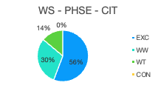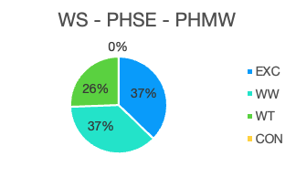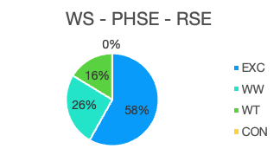
In Citizenship 86% of pupils (37 pupils) are exceeding or working within their targets, in Physical Health and wellbeing 74% of pupils (32 pupils) are exceeding or working within their targets and in Relationships Education 84% (36 pupils) are exceeding or working within their targets.
92% of females are working within or exceeding their targets in Citizenship while 84% of males are excelling in the same dataset. In Physical Health and wellbeing 90% of females are working within or exceeding their targets 80% of males are working within or exceeding their targets in this area. 93% of females are working within or exceeding their targets in Relationships Education outperforming the 83% of males who are excelling in the same dataset.
FSM
For the purpose of this dataset there are 52 students in the main bulk of the cohort, 32 of which are male accounting for 61% of this cohort, 20 are female accounting for 38% of this cohort.
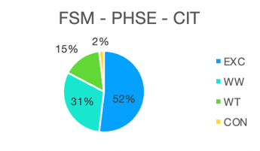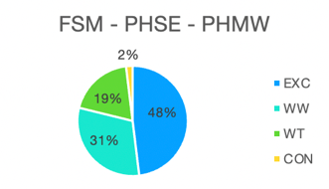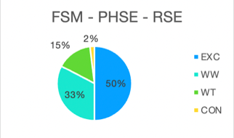
In Citizenship 83% of pupils (43 pupils) are exceeding or working within their targets, in Physical Health and wellbeing 79% of pupils (41 pupils) are exceeding or working within their targets and in Relationships Education 83% (43 pupils) are exceeding or working within their targets.
80% of females are working within or exceeding their targets in Citizenship while 84% of males are excelling in the same dataset. In Physical Health and wellbeing 75% of females are working within or exceeding their targets 81% of males are working within or exceeding their targets in this area. 75% of females are working within or exceeding their targets in Relationships Education outperformed by the 87% of males who are excelling in the same dataset.
LAC
For the purpose of this dataset there are 9 students in the cohort, 6 of which are male accounting for 54% of this cohort, 3 are female accounting for 46% of this cohort.
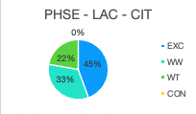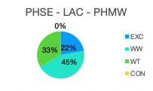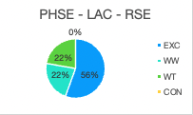
In Citizenship 78% of pupils (7 pupils) are exceeding or working within their targets, in Physical Health and wellbeing 67% of pupils (6 pupils) are exceeding or working within their targets and in Relationships Education 78% (7 pupils) are exceeding or working within their targets.
67% of females are working within or exceeding their targets in Citizenship while 83% of males are excelling in the same dataset. In Physical Health and wellbeing 67% of females and males are working within or exceeding their targets. 67% of females are working within or exceeding their targets in Relationships Education outperformed by the 83% of males who are excelling in the same dataset.

Overall progress of pupils in Key Stage 4

● 70% of pupils are making expected progress or above expected progress in English
● 61% of pupils are making expected progress or above expected progress in Mathematics

Key Stage 4

English

For the purpose of this dataset there are 21 pupils in the cohort, 11 of which are male accounting for 52% of the population, 10 are female accounting 48% of the population. 70% of pupils are making expected progress or above expected progress in English.

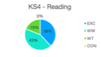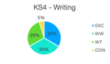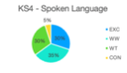

In reading 80% of pupils (21 pupils) are exceeding or working within their targets, in writing 66% of pupils (21 pupils) are exceeding or working within their targets and in Spoken language 65% (28 pupils) are exceeding or working within their targets.

80% of females are working within or exceeding their targets in reading while 81% of males are excelling in the same dataset. In writing 70% of females are working within or exceeding their targets, 46% of males are working within or exceeding their targets in this area. 60% of females are working within or exceeding their targets in spoken language being outperformed by the 64% of males who are excelling in the same dataset.

Key Stage 4

Mathematics

For the purpose of this dataset there are 21 pupils in the cohort, 11 of which are male accounting for 52% of the population, 10 are female accounting 48% of the population. 61% of pupils are making expected progress or above expected progress in Mathematics.

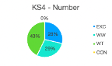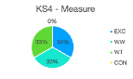

In number 57% of pupils (21 pupils) are exceeding or working within their targets, in measure 67% of pupils (21 pupils) are exceeding or working within their targets

70% of females are working within or exceeding their targets in number while 45% of males are excelling in the same dataset. In measure 50% of females are working within or exceeding their targets, 81% of males are working within or exceeding their targets in this area.

Conclusion

At the Cavendish High Academy pupil outcomes are outstanding, this judgement is based not only on the progression evidenced within this report but also the holistic measures we as professionals impart upon the students in our care. At Cavendish each student is truly unique, this is acknowledged, and aims are well thought out through in-depth Positive Behaviour support plans, Personal learning plans and suites of assessment that support EHCP outcomes and individuals on their individual learning pathway ensuring that they thrive.

Detailed analysis of end of year and within key stage progress shows that many pupils make exceptional progress in most areas of learning and development.

Almost all students at the end of year 11 continue into post 16 education at Cavendish, the school remains oversubscribed with strong parental preference for their children to transition into year 7 and remain at the school post sixteen. Those who don’t are supported into their transition phases with strong support both from the school and the SEN Assessment team with whom we have built up a strong relationship over many years.

Externally provided programmes
Please include the names of any non-DfE programmes that you used your pupil premium (or recovery premium) to fund in the previous academic year.
Programme | Provider
DESTY | https://www.educationdesty.com/
The Good Life  Wellbeing and counselling service | Dramatherapy (Ceased July 2023)  (Specialising in Trauma & PTSD)

Further information
At the Cavendish High Academy pupil outcomes are outstanding, this judgement is based not only on the progression evidenced within this report but also on the holistic measures we as professionals impart upon the students in our care. At Cavendish each student is truly unique, this is acknowledged, and aims are well thought out through in-depth Positive Behaviour support plans, Personal learning plans and suites of assessment that support EHCP outcomes and individuals on their individual learning pathway ensuring that they thrive.
Detailed analysis of end-of-year and within-key stage progress shows that most pupils make exceptional progress in most areas of learning and development.

