Pupil Premium Strategy 2020-2021

The Cavendish High Academy

Pupil Premium Funding September 2020 – July 2021

The Pupil Premium Grant (PPG) 2020-2021 provides funding to raise the attainment of disadvantaged pupils and closing the gap with their peers. As a school, we have the responsibility for using this funding to close the gap for this specific cohort of learner. We ensure the best possible support for raising attainment for the most vulnerable pupils. Equality remains the core of all we do at Cavendish.

The Pupil Premium Grant per eligible pupil (in yrs. 7-11) for 2020 to 2021 was £955, an increase of £20 per head

The Cavendish High Academy Pupil Premium Grant 2020 -2021
Total number of pupils on roll | 92
Total number of pupils eligible for PPG | 44
Amount of PPG per pupil | £955
Amount of PPG received | £42,308.46
% of school yrs. 7 - 11 accessing PPG | 48%
Total number of Pupils eligible for Pupil Premium Plus for Children in Care | 7
PP Plus per pupil | £2345

What we invested in to support our most vulnerable learners 2020-2021:

- Employed: Speech and language therapist,1 part-time (0.6):
Assess pupils, baseline and ascertain level of support required Write Speech and Language programs
Undertake sensory diet assessment & create sensory diets for individuals as required
Provide training for staff e.g. BLANK levels, sensory diet
Attended meetings with parents and annual review/EHCP meetings
Develop communication strategies with pupils based on a specific need

Cost to school £ 26,586.88

Provided financial support for enrichment & extended provision activities to enable participation for those pupils who are most disadvantaged:

- Literacy – Subscriptions to the Book Trust to support two young people’s literacy and promote a lifelong love of books
- ICT Equipment – supporting two pupils with social, emotional and mental health needs, in addition to providing educational IT support within the classroom
- Sensory equipment - toys, games and safety equipment

Cost to school £2,232.93

Bought furniture, equipment, materials and resources to support pupils emotional and physical health and well-being to promote their readiness for learning in an appropriate environment:

Identification of nurture groups and the design, construction and furnishing of specialist
provision to meet the needs of these pupils as they progress through the school.
(room modification, division, furnishing and resourcing)

Investment in Widgit online, a literacy scaffolding and symbolization tool.

Remaining budget allocated towards these improvements to the fabric and infrastructure of the school (£13,488.65)

Cohort

Pupil Premium

44 pupils are entitled to Pupil Premium across the school; these pupils account for 48% of the whole school population, 30 of these pupils are male (69%) and 14 are female (32%). These pupils only appear in key stages 3 and 4.

Overall progress of pupils in Receipt of Pupil Premium

- 61% of pupils are making expected progress or above expected progress in English
- 70% of pupils are making expected progress or above expected progress in Mathematics
- 64% of pupils are making expected progress or above expected progress in PHSE
- 89% of pupils were assessed as being ‘fully’ or ‘partially engaged
- 39% of pupils were described as being ‘highly’ impacted as a result of the pandemic

Cohort

LAC - Looked after Chidren

There are 7 looked after pupils in the Academy, (5% of the whole school population) of those 5 are male (5% of the whole school population) and 2 of those are female (2% of the whole school population).

Overall progress of pupils who are looked after

- 100% of pupils are making expected progress or above expected progress in English
- 100% of pupils are making expected progress or above expected progress in Mathematics
- 86% of pupils are making expected progress or above expected progress in PHSE
- 100% of pupils were assessed as being ‘fully’ or ‘partially engaged
- 0% of pupils in this category were described as being ‘highly’ impacted as a result of the pandemic

Impact

Pupil Premium pupils were the second highest performing cohort across the school across English, Mathematics and PHSE. Below is a breakdown of their performance by category including engagement and impact profiles specifically related to the ongoing pandemic.

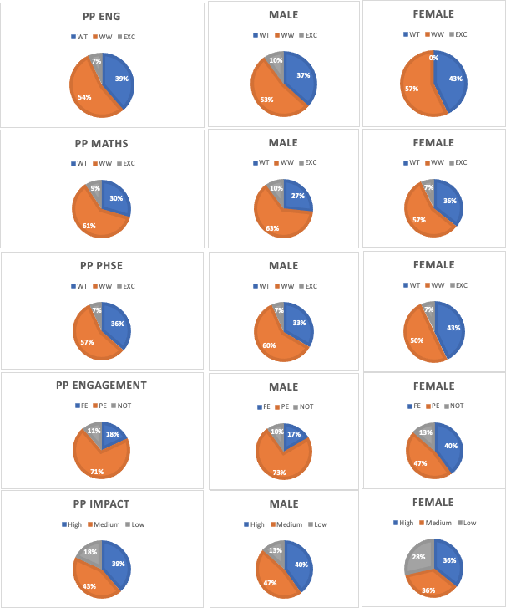

LAC - Looked after Children

LAC pupils performance figures are exceptional even in comparison to previous years, again these are a very small portion of the whole school population (7) with a high proportion of ‘high flyers’ amongst their ranks.

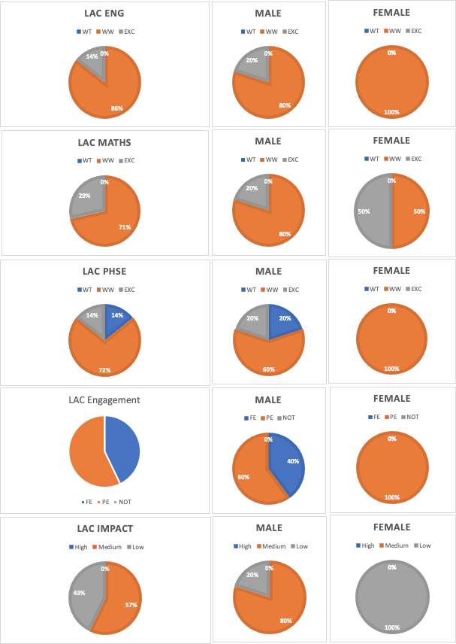

Both cohorts are performing exceptionally well in comparison to other groups across the academy, the strategy in place to support these cohorts remains effective and well managed.

