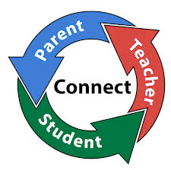

**Cavendish Connect**

**Dear Parents & Carers,**

The summer term is now well underway and we are all following the changes to guidance for schools with regards to living with Covid. There is no longer a requirement to wear masks on school premises but staff and children are welcome to do so if they choose.

None of us knew quite what to expect with restrictions lifting and ‘living with Covid’ coming into being. As you may be aware we had a very difficult Spring Term as a staff team due to the rate of Covid infections amongst us. Thankfully we seem to now be through the other side and we are thoroughly enjoying having a school without bubbles!

We are fortunate that we have do still have a stock of Lateral Flow Tests so if your child is unwell with Covid symptoms you can request a testing kit for them.

**Please note:** Any child who is ill with a high temperature will need to remain off school until they no longer have a high temperature as per government guidance.

**The Legends known as The Jolly Boys**

We are so very fortunate to have an amazing group of people called The Jolly Boys who support us by fundraising for the school and our students. They have been working tirelessly to raise funds; initially to support our first post-covid residential trip to Barnstondale for classes C9 & C10. At the end of the Spring Term they held two fundraisers - an Easter Bingo & a sponsored long distance hike.

**Easter Bingo**

Thank you to all of you who were able to attend the Easter Bingo on Friday 1st April which was very kindly hosted by Paul Jameson at the Bridge View. Your support was very much appreciated and we are delighted to tell you that you helped to raise over £1000 for the school.

**Hadrian’s Wall Adventure**

Over the Easter bank holiday, the Jolly Boys gave their own time to undertake a massive challenge, a hike along Hadrians Wall. We are so very grateful to each and everyone of them for their time and effort undertaking this massive challenge. We appreciate their feet will never be the same again!

The jolly Boys have now raised over £15,000 this year alone and this money will be used to make the Barstondale trip an unforgettable experience for our young people and will also now help to update & refurbish the bungalow, our independent living base.

The Cavendish High Academy Newsletter / Summer 2022

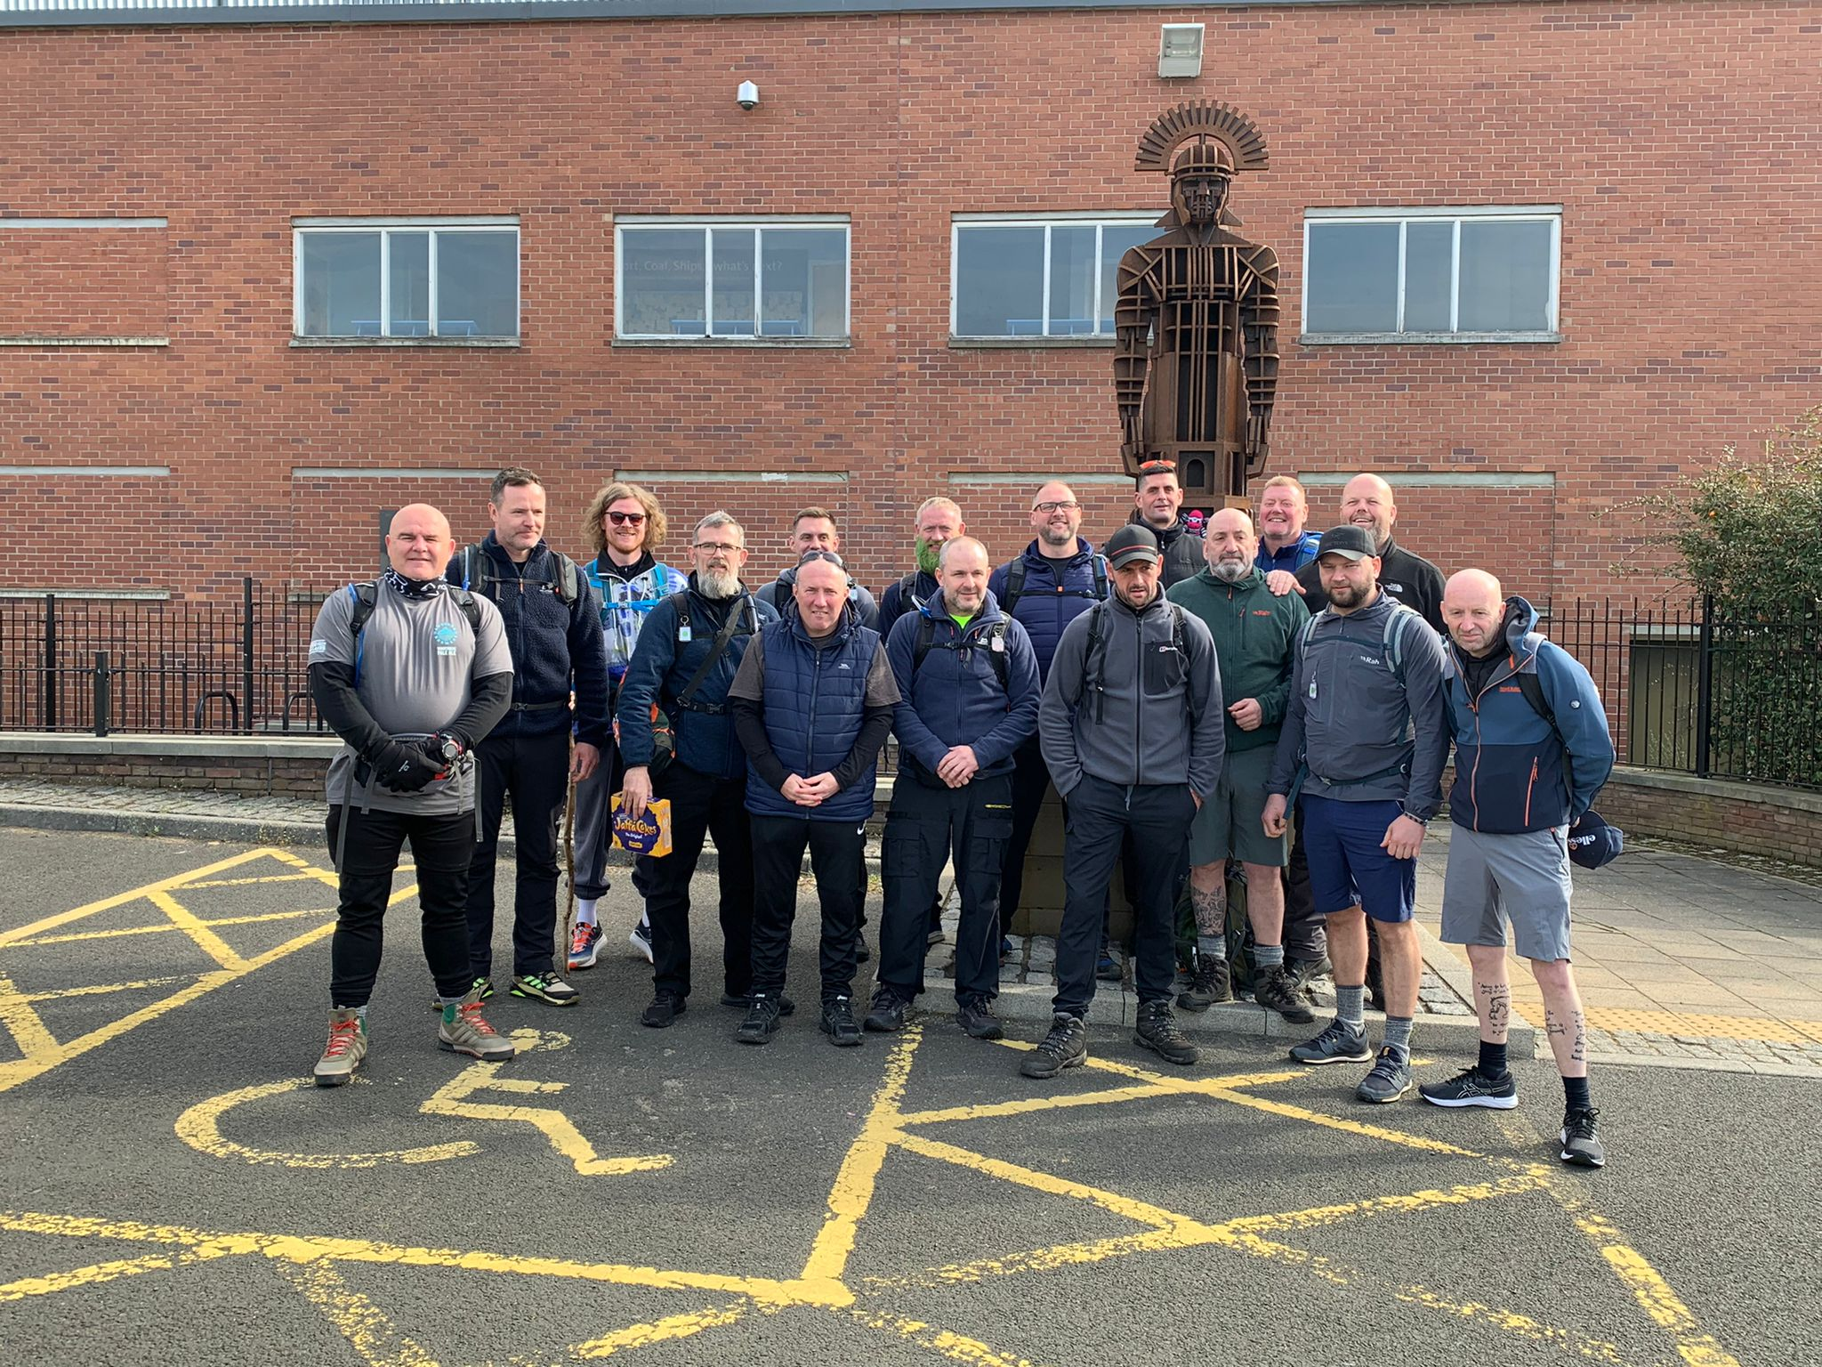

On their way

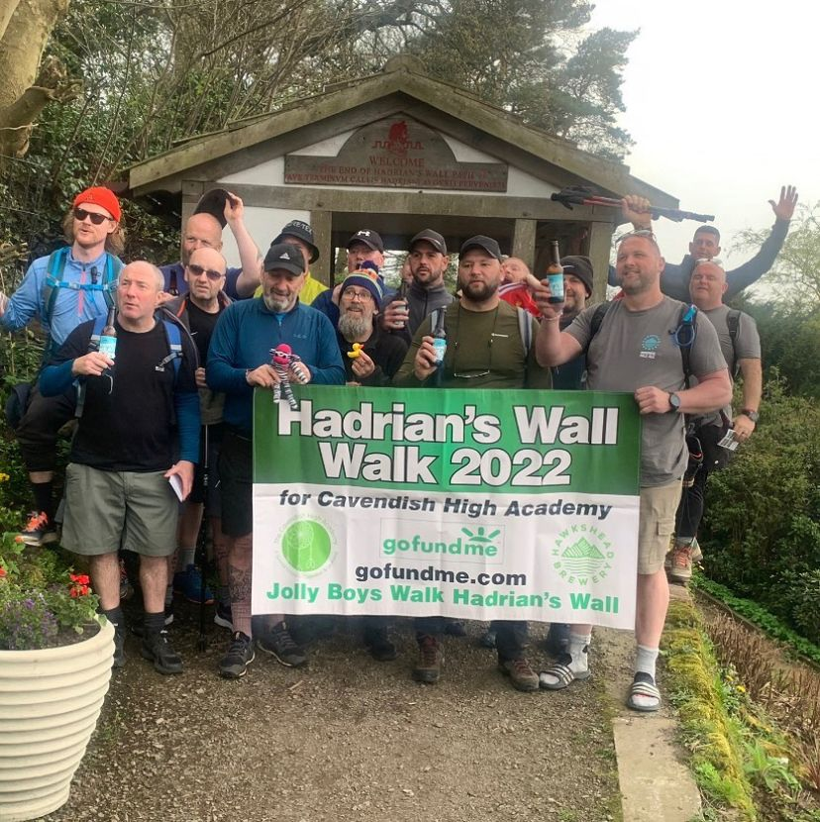

Rectangle 








**Queens Platinum Jubilee**

The students will be celebrating the Queens Platinum Jubilee in school on Friday 27th May with a ‘street party ‘in the playground.

**Governors**

We are delighted to welcome Kayleigh Harding to the Board of Trustees of the Academy as a parent governor representative. We need you to help ensure we can continue to provide the best education we can for your children. We still have a second vacancy for a parent governor. Would you be interested in the role? If you would please contact us and we can let you have some more information about what it all entails and/or you can speak to our current governors who will gladly share their experiences of being on the board.

**Leavers**

The last day in school for our Leavers will be Friday 24th June. Unfortunately, as in the previous 2 years the Cheshire Schools Consortium is not holding a Cathedral Celebration this year but we will be having alternative celebrations that are currently being planned by the students. Watch this space….

**Parents & Carers Open Evening**

We are so excited to be able to welcome you all back into the school for a parents & carers open evening on Wednesday 22nd June (time tbc). You will be able to speak with your child’s current class team, look at their work and have a look around school as well as being able to meet members of their new staff team for the next school year.

**Transition**

We’re already very busy making plans for the next academic year and have been organising classes and staffing for Sept 2022- July 2023. We are aiming for the whole school to move into their new classrooms/groups on Monday 4th July. We fully appreciate how difficult change and transition can be for your sons and daughters. This early transition means that we will be able to do our best to settle the children into their new rooms & groups and that the staff can get to know their classes before the summer holidays. We find this can help to reduce anxiety over the holiday period as everyone knows where and who they are coming back to in September.

There are more classes than usual moving classroom; we are expecting some significant building work to take place over the course of the next academic year and are making accommodations in anticipation of this to minimise disruption. I am sure you fully appreciate the need for us to ensure we are all prepared. The plan is for Thursday 30th June to be our last day in our current classes and classrooms.

**Diary Dates**

We have an **INSET** day planned for **Friday 1st July**. School will be closed to all students. When students return to school on Monday 4th July it will be to their new classroom and staff team. We will be working with the students on preparing for any changes and class teams will as ever be in touch with you too so we can work together to support your child.

A quick reminder that the Whit holiday is two weeks long this year. We break up on Friday 27th May at usual time and return on Monday 13th June. (6th June is a day in lieu of the Queen’s Jubilee and the other 4 days are INSET).

The Final day of the summer term is Wednesday 20th July and school closes to students at 1.30pm.

It leaves me to say many, many thanks to all of the staff who have given their own time to support school fundraisers and also to thank each and every one of you who have given your support as well. It’s great to be working together for all of your children.

Here’s to a great summer term, where hopefully you will see the school minibus out and about again, as we ‘get back to business as usual’ at Cavendish.

Take care,

Elaine & all the team at Cavendish